STUDENT GOVERNMENT SENATE AGENDA
Wednesday, September 13, 2017
9:00 – 11:00 a.m.
Coville Conference Room

Notice
NOTICE IS HEREBY GIVEN to the general public and to all members of the CSU Channel Islands Student Government that:
A meeting of the Student Government Senate will be held on Wednesday, September 13, 2017 at 9:00 a.m. at California State University Channel Islands, Student Union Conference Room (room 1080), located at One University Drive, Camarillo, CA 93012, to consider and act upon the following matters:

Call to Order - 9:13 AM

Roll Call

Legislative

  - Senator of Academic Affairs
  - Senator of Alumni, Graduate & Credential Matthew Federis (P)
  - Senator of Commuters & Transportation
  - Senator of Housing & Residential Education
  - Senator of Social Justice Mia Fernandez (P)
  - Senator of Student Engagement Noelle Ewing (P)
  - Senator of Sustainability & Technology Raul Perez (P)
  - Senator of Veterans & Non Traditional
  - Senator of Wellness & Recreation Angela Christopher (P)

Executive

  - President Karina Hinojosa (P)
  - Vice President Alexis Mumford (P)
  - Director of External Affairs Samuel Martinez (P)
  - Director of Operations Lisa Mireles (P)
  - Director of Events
  - Chief of Staff Chelsea Lincoln (P)

Judicial
  - Chief Justice

Advisors

  - Bethany Bañuelos (L 9:19 AM)
  - Helen Alatorre (P)

Members of the public

- Ray Porras
- Andrew Larenzana
- Sary Nguyen
- Annie Block-Weiss

Approval of the Agenda
- September 13, 2017
  - Senator Fernandez motioned to approve the agenda
  - Motion seconded by Senator Christopher
  - Senator Federis motioned to amend the agenda and remove the 45 minutes under special presentations
  - Motion seconded by Senator Fernandez
  - 5 in favor – 0 opposed – 0 abstentions to amend the agenda
  - 5 in favor- 0 opposed – 0 abstentions to approve the agenda

Approval of the Minutes
- September 6, 2017
  - Senator Christopher motioned to approve the minutes
  - Seconded by Senator Fernandez
  - Senator Federis motioned to amend the minutes to edit closing comments made by Senator Federis in regards to the CI Republicans club meeting to include that it was for specifically for the DACA event
  - Motion seconded by Senator Perez
  - 4 in favor – 0 opposed – 1 abstention to amend the minutes
  - 5 in favor – 0 opposed – 0 abstentions to approve the minutes

Public Forum
Public forum is intended as a time for any member of the public to address the Senate on issues affecting any student(s) and/or organizations of California State University Channel Islands.

Reports
Reports presented by the following shall be attached with all weekly packets. Weekly packets will consist of agenda, any supporting documents, minutes, and reports.

- Legislative Reports
- Vice President’s Report
- President’s Report
- Executive Branch Report
- Judicial Report
- Advisor Report
- Committee Report

Special Presentations (45 minutes)

Unfinished Business
- None

Informational Item

Discussion Item

Action Item (President Hinojosa 15 minutes)
  - Director of Events Appointment Katie Mitchell
    - President Hinojosa has nothing to add from the last meeting in regards to Katie Mitchell
    - Senator Fernandez motioned to approve Katie Mitchell as Director of Events
    - Seconded by Senator Perez
    - Vice President Mumford opened up discussion on any additional thoughts in regards to Katie’s answers
    - 5 in favor – 0 opposed – 0 abstentions

New Business

Informational Item (Director Martinez 10 minutes)
- Constitution Day
  - Director Martinez talked about Constitution Day and gave a presentation, which will be added as a supporting document
  - Director Martinez opened the floor for questions
    - Vice President Mumford asked if he’d like the Student Government members to wear patriotic attire to which Director Martinez agreed
    - Advisor Alatorre asked how many volunteers Director Martinez will need for this event
      - Director Martinez replied that he will need 10 volunteers to sign up for 30-minute shifts and advised anyone interested to see him after the meeting

Discussion Item (Vice President Mumford 60 Minutes)
- Let’s Talk DACA Logistics
  - Vice President Mumford went over the logistics page and this document will be added as a supporting document
  - Advisor Alatorre mentioned that the event was initially only supposed to be advertised via social media and is now confused about the flyers
  - Senator Fernandez mentioned that the wanderers can help rather than just holding signs, they can walk around and talk to people and encourage their participation
  - Senator Christopher mentioned that the arrows are not a bad idea so long as they are legible and students are able to follow them easily because the courtyard is a difficult location to arrive to
- Minute to Win It Logistics
  - Vice President Mumford went over the logistics page and this document will be added as a supporting document
  - Vice President Mumford asked if anyone had further ideas for tabling methods
    - Senator Perez yielded time to Chief Lincoln
      - Chief Lincoln mentioned that she thinks the activities should be done before the event as a “feeler” for everyone and will have activities sent to Vice President Mumford by today
  - Vice President Mumford asked what everyone’s thoughts were about having members wear tie-dye t-shirts and hand out flyers as an interactive marketing method
    - President Hinojosa agreed that the tie-dye shirts are a good idea and there should also be activities and prizes out as a “teaser” of what students can win if they attend
    - Senator Ewing asked what marketing will look like, specifically on Instagram
      - Senator Perez yielded time to President Hinojosa
        - President Hinojosa stated that the flyer will be posted on the Instagram and Director Mireles will be creating and posting additional flyers as well
      - Senator Christopher yielded time to Chief Lincoln
        - Chief Lincoln asked if there were any tie-dye shirts already readily available and if it would be possible to start advertising for this event today
          - Vice President Mumford stated that the shirts are ready and members are able to begin advertising
  - Vice President Mumford asked if any members had additional ideas or thoughts about this event
    - Senator Christopher asked if we will have a Snapchat geofilter for this event
      - President Hinojosa responded that she is unsure but thinks we requested one
    - Senator Perez yielded time to President Hinojosa
      - President Hinojosa mentioned that she will contact and invite Katie Mitchell to attend the DACA event and she and President Hinojosa will be the point people
        - President Hinojosa asked that all members send her any infringements or prior obligations that will get in the way of this event

Action Item
- None

Closing Comments
- President Hinojosa closed the conversation discussing a link sent to her by Carisa and asked that every member please complete it and submit it as soon as possible
- Senator Fernandez mentioned that there will be an Open Mic night at the Writing and Multiliteracy Center tonight from 6:00-8:00 PM in the Broome Library as an opportunity to have fun and network
- President Hinojosa mentioned that there is a member of the public interested in becoming a senator so please say “hi!” and engage with him

Adjournment – 10:01 AM
- Senator Federis motioned to adjourn
- Senator Christopher seconded this motion
- 5 in favor – 0 opposed – 0 abstentions to adjourn

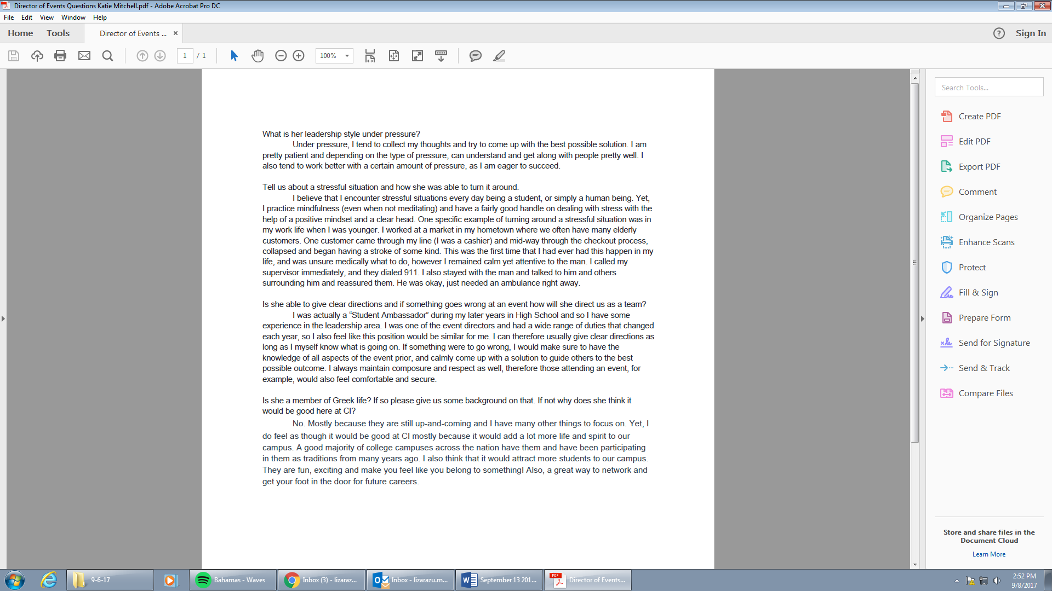
Let’s Talk DACA
Vice President

Basic Info

Date
Thursday, September 14

Time
3:00-4:00 pm

Location
Sub Courtyard

Marketing
Use political and cultural clubs on campus. Shout out in your class.

Interactive
Handing out flyers

Passive

Day of
- Tabling?
- Posted flyers?

Social Media

Instagram
- Posting before event and tagging clubs

Snapchat
- Geofilter?

Day of

Before

Setup
Help with Setup at 2:30

Resources
60 Chairs
2-3 rectangular Tables
Round tables
AV Equipment: Student Union
3 mics

Volunteers
Need a list of all member attending

Assignments
2-3 Arrows
2 People walking around with flyers

During

Assignments

Point Person
Alexis Mumford

MC’s (3)
Martha Zavala

Question Takers(2)

Wanderers(2)

Nathan and Angela

Tabling
- College Republicans
- College Democrats
- Libertarian Club
- Democratic Socialist

After

Cleanup
4:15-4:30 P.M.
Put away chairs & tables
Help Student Union with anything they need

A-Frame
Pickup

Minute to win it with Student Government

Basic Info

Date
Thursday, September 21

Time
7:00-9:00 pm

Location
Sub Courtyard

Marketing

Interactive

Tabling
- Fun tabling ideas that get people involved
- Constitution day

Tie Dye shirts
- Going around in tie dye shirts passing out flyers

Classrooms
- Ask your professor if you can make announcement, and also ask your professor to make announcements in their other classes

Clubs
- Who do I know that is a club officer who can tell their club?
- Get digital signage to give to other clubs

Passive

A-Frames (8)

News Center

Flyers
- Drop off at Student Union, housing, and entities office

Social Media

Resources

Equipment
A.V.
Mics ()
Extension cord
Speakers
Trash cans

CI Radio
Get CI Radio to play music

Furniture
Stage
Rectangular Tables ()
Circular Tables ()
Chairs ()

Activity
Minute to win it games and last 30-45 mins students get to ask sg members questions

