 | Student Government Senate minutes (draft)  Wednesday, February 22, 2017  9:00 – 11:00 a.m.  Coville Conference Room

Notice
- NOTICE IS HEREBY GIVEN to the general public and to all members of the CSU Channel Islands Student Government that:

A meeting of the Student Government Senate will be held on Wednesday, February 22, 2017 at 9:00 a.m. at California State University Channel Islands, Student Union Conference Room (room 1080), located at One University Drive, Camarillo, CA 93012, to consider and act upon the following matters:
Call to Order
- Call to Order – 9:00 a.m.
- Roll Call
  - President – Michelle Noyes (P)
  - Vice President – Marlene Pelayo (P)
  - Senate
    - Academic Affairs – Travis Hunt (P)
    - Alumni, Graduate & Credential – Kiera Sailor (A)
    - Commuters & Transportation –
    - Housing & Residential Education – Reymundo Massie (P)
    - Social Justice – Mia Fernandez (P)
    - Student Engagement – Noelle Ewing (p)
    - Sustainability & Technology – Raul Perez (P)
    - Veterans & Non Traditional – Nathan Altman (P)
    - Wellness & Recreation – Debora Ehrich (P)
  - Executive
    - Director of External Affairs – Carla Mena (P)
    - Director of Operations – Karina Hinojosa (A)
    - Director of Events – Alexis Mumford (P)
    - Chief of Staff – Angela Christopher (P)
  - Judicial
    - Chief Justice – Brandon Burns (P)
    - Associate Justice – Jack Holden (A)
    - Associate Justice – Jorge Robles (A)
  - Advisor –
    - Bethany Bañuelos (P)
  - Members of the public
    - Chelsea Lincoln
    - Felix Julian Pambuena
    - Kaela Casey
    - Celina Zacarias
    - Ray Porras
    - Sandy Gannon
    - Annie Block-Weiss
    - Genesis Delong

- Approval of the Agenda
  - Motion to approve by Senator Altman
  - Seconded by Senator Ewing
  - 7 in favor – 0 opposed – 0 abstentions
- Approval of the Minutes
  - Minutes from February 8, 2017
    - Motion to approve by Senator Hunt
    - Seconded by Senator Erich
    - Senator Altman asked to see the minutes from Feb. 8
    - 6 in favor – 0 opposed – 1 abstention
  - Minutes from February 15, 2017
    - Motion to approve by Senator Ewing
    - Seconded by Senator Erich
    - 7 in favor – 0 opposed – 0 abstentions

Public Forum
Public forum is intended as a time for any member of the public to address the Senate on issues affecting any student(s) and/or organizations of California State University Channel Islands.
- President Noyes stated that she would like the senate to correct the minutes as they are being written this week
- Celina Zacarias commended SG members who met with Assemblywomen Jacqui Irwin

Special Presentations
- Special Presentations – none

Business
- Unfinished Business – none
  - Informational Item - none
  - Discussion Item – none
  - Action Item – Maximus Selection Committee – Director Mumford (10 minutes)
    - Director Mumford presented the nominations for the Maximus committee, alternates, and is seeking for an approval by the Senate.
    - Senator Ewing asked to see the whole list of nominations.
    - Director Mumford stated that the SSS nomination and Senator Sailor declined their nominations. There will be a new SSS representative and Isaiah Ball will need to have an academic and judicial check before being nominated as the SG member.
    - Advisor Banuelos stated these nominations were selected by their departments.
    - Motion to approve the nominations by Senator Ewing
    - Seconded by Senator Erich
    - 7 in favor – 0 opposed – 0 abstentions
- New Business
  - Action Item –
  - Informational Item –
    - Active Shooter SWOT – Events Committee (10 minutes)
      - Director Mumford presented the Active Shooter SWOT form the Event Committee.
      - No comments
    - CSSA San Francisco State Update – President Noyes and Director Mena (5 minutes)
      - Director Mena covered the Legislative Committee from CSSA; legislation that was supported and legislation that was discussion items
      - President Noyes gave updates on the University Affairs committee. A mental health resolution was passed with amendments, faculty evaluations resolution, and there was not food and housing insecurity resolution.
      - Director Mena gave updates from the advocacy committee about Hill day and systemwide lobbying efforts
      - President Noyes gave updates from the Board of Directors at CSSA.
  - Discussion Item –
    - Library Collaboration – Kaela Casey (30 minutes)
      - The library provides distress events during dead week for students. Averages 500 students and lasts for a week. It costs $800 to provide coffee, tea and essentials at the best price possible. The last academic year 15-16 the library went over by about $150. The library has gone over $800 in the fall semester and has received a $200 sponsorship from Student Programming Board. The library is asking for $200 from Student Government to provide these services.
      - VP Pelayo states this is a discussion item and will be brought back as an action item
      - Director Mumford states that we have money left over from our events food budget.
      - Senator Ewing asked how long the coffee lasts during the night.
      - Senator Hunt asked to see the SG budget.
      - Senator Ewing asked if the library is seeking campus donations.
      - President Noyes shared the SG budget with the Senate.
      - Director Mena announced Celina Zacarias would like to donate $100.
    - Special Rules Resolution – Senator Hunt (30 minutes)
      - Senator Hunt presented the resolution to the Senate. The resolution includes that standing up causes problems in the SG meetings and to eliminate speaking twice because it will hinder the operations in SG meetings.
      - Senator Altman asked how Senator Hunt knew speaking twice would prohibit SG.
      - Senator Hunt answered that with a small group and having to yield time to the executives speaking twice is not enough.
      - Senator Ewing asked if this was a discussion item. This will be coming back as an action item.
    - Tuition Increase Resolution – Senator Ehrich (30 minutes)
      - Senator Erich presented the resolution with ASI’s edits to the Senate.
      - Chief Burns read the resolution aloud.
      - Advisor Banuelos reviewed the ASI suggestions, which were made with track changes, at the meeting. A suggestion is to provide stronger language including in opposition against the increase in the whereas. Offered that someone who is an expert on campus can review the resolution.
      - Director Mena asked if everyone should email Senator Erich what should be revised.
      - Senator Erich answered that either emailing or meeting in person will work to talk about the resolution.
    - Elections Council Update – Vice President Pelayo (5 minutes)
      - There has not been a lot of face to face interaction for advertising Student Government. VP Pelayo encourages members who are not returning to table and create a video blog including talking to constituents or day to day responsibilities. VP Pelayo encourages members to pass out flyers and talk to classes to run for a position.

Reports
Reports presented by the following shall be attached with all weekly packets. Weekly packets will consist of agenda, any supporting documents, minutes, and reports.

- Senator Reports
- Vice President’s Report
- President’s Report
- Executive Branch Report
- Judicial Report
- Advisor Report

Adjournment
- Closing Comments
- Adjournment – 10:06 a.m.
  - Motion by Senator Hunt to adjourn
  - Seconded by Senator Altman
  - 7 in favor – 0 opposed – 0 abstentions

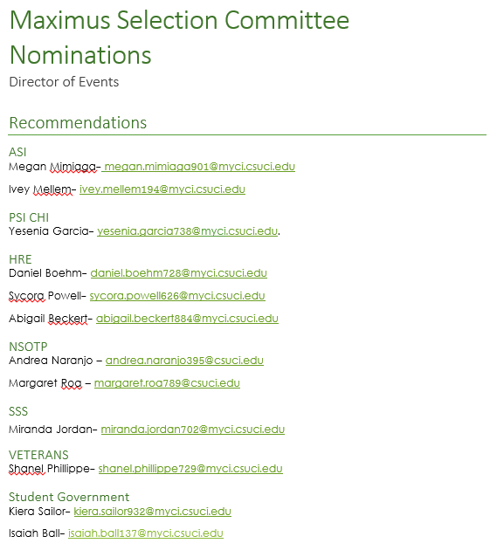

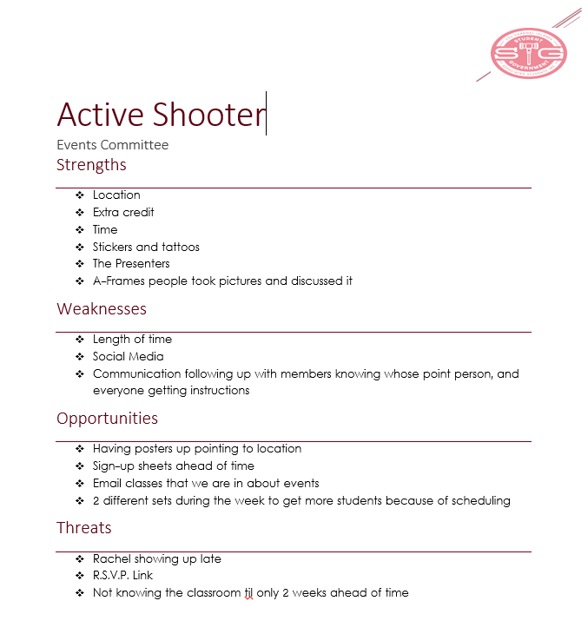

Supporting Documentation
CSSA notes from February 18-19, 2017
Committees
- Legislative Affairs
  - Special presentation – CFPB – consumer federal protection bureau
    - 2016 Q4 total: $1,406.9 billion ($1.4 trillion) (was $600 billion 10 years ago)
    - Mortgage debt is the only one higher
    - Public repayment – 10 years work for the public and paying loan debt then forgive the rest
    - students@cfpb.gov presentation for students
- Bridge act – Bar removal of Individuals who Dream and Grow our Economy) – support
- Student loan repayment parity act – support
- Law enforcement – CA Values Act – support
- Modernization – CCC count for AB 540 – support
- Discussion items
- AB 17 Transit Pass Program – free or reduced transit passes to pupils and students
- AB 214 College student hunger – written notice to Cal Grant recipients for CalFresh
- AB 216 Prepaid postage on Vote-By-Mail Ballots – may not fall into CSSA guidelines to support legislation – will be action item
- AB 393 Mandatory Systemwide Fees and tuition
- Scientific Leadership Consensus statement – UC Davis supports objective science in policy – David sending more info, March action item
- University Affairs
  - DREAMer Ally training
    - Sac state program focuses on 1. Access 2. Campus culture 3. Increase retention and graduation rates
    - DACA students can continue to receive financial assistance from CA. DACA is not a law, executive order
  - Systemwide faculty evaluations resolution – updated
  - Mental health resolution – approved with amendments
  - Food and housing insecurity resolution – no resolution drafted, will be at a zoom meeting
  - Work with alumni office to have nominee for CSSA alumni of the year by March meeting
- Advocacy committee
  - Chess 2017
  - May advocacy event
    - March 30 in district lobbying
  - Alumni advocacy day
  - March tuition walk out
    - Support an action day
- Finance committee
  - Review financial statements
  - 17-18 Budget development
  - Didn’t meet quorum
  - Discussion about CSSA budget priorities: Advocacy in all forms (local, state, federal, execs, board members)
- SJEC
  - Resolution supporting undocumented student in the CSU
  - Ethnic students resolution
  - African/black student success in the CSU
- BOD
  - Reports
    - Academic Senate CSU
      - Lactation stations on campuses
      - Tax reform of Ca master plan higher ed, for eventually free higher ed
      - Chancellors
        - College health report – ask VPSA for report on CI,
        - Students healthy, mental health, well being
        - New CDSU application that is more students friendly, not CSUmentor (new June 1)
        - CSU appeal on residency app if rejected (120 days to fill out form to 30 days) try to make process from 6-7 months to 3-4 months
  - Potential tuition increase updates
    - Advocacy day (with faculty, staff, admin)
      - CHESS 3/12-3/13
      - 3/14 CSU Advocacy Day (Celina attending)
      - 4/3-4/4 CSUEU advocacy day
      - Academic Senate advocacy Day
      - 4/24 Golden Bear boat reception
      - 5/2 CSSA advocacy?
      - CSUEU CSU bargaining union (Cynthia County rep)
    - Messaging
      - #ChooseCSU
      - Cards to write on and leave behind
  - Policy agenda review
    - Worked on about half or assigned any tasks to Staff students weren’t able to get through
    - Hill Day update soon – before CHESS, Carla is connecting with Celina
  - Legislature of the year
    - Shirley Weber - Assembly Member, District 79, San Diego region. Serves on the higher education committee. Has chaired in the past the select committee on campus climate. A professor at San Diego State in Africana studies. Remains a champion on Food insecurity, Last year AB 1747, and will continue to push legislation on this issue.
  - Federal leg
    - BRIDGE Act – support
  - State leg
    - Student loan repayment parity – support
    - Law enforcement: sharing data – support
      - Cal poly slo academic senate passed resolution ICE cannot come to campus without a warrant
  - Special officer edits – removed from the agenda
  - Executive mid-year review – Approved
  - Walk out against tuition increase
    - CSULA – silent sit in, not to miss class, artwork, March 15
      - Make CSU Students a Priority (Fresno, Fullerton, LA) for May Advocacy Day
        - Student rally
        - March out
        - Same color shirt for solidarity
        - Media convocation
        - Campuses will commit to certain tactics
        - That day students lobbying will show legislators social media of what is happening at campuses
        - (other: Video)
        - April plenary hear tactics
        - Happen on May 2 or 3
    - MECHA may be having a walk out on March 1… Carla will follow up
    - Agenda discussion and action item at a SG meeting –assignments for initiatives
  - Middle class scholarship – support
  - Resolution undocumented students – removed
  - Resolution ethnic studies – removed
  - 17-18 budget development
    - Finance Committee: Survey and phone calls to see what board members priorities are for next year
  - Discussion of the purpose of CSSA

Special Rules Resolution for Senate Meetings
Issue: Student Government has identified a problem in the senate meetings. According to Robert’s Rules of Order, members must stand up and address the chair, also they are limited to only speaking twice during any discussion.
Whereas: Student Government finds this to be highly inefficient for the size of Student Government.
Whereas: Student government knows that only speaking twice during a discussion can severely hinder the operations in Student Government Senate meetings.
Whereas: Limiting discussion lowers the productivity, and prevents ideas from coming to Student Government as a whole, which hurts the student population.
Resolved: We at Student Government have decided to implement special rules to eliminate the speaking twice rule. Also we wish to move from standing up, and addressing the chair to a simple placard raise.


STUDENT GOVERNMENT
CALIFORNIA STATE UNIVERSITY CHANNEL ISLANDS
CALIFORNIA STATE UNIVERSITY CHANNEL ISLANDS * 1 UNIVERSITY DRIVE * CAMARILLO, CA 93012 * SG.CSUCI.EDU

A Resolution in Opposition to the California State University
Potential Tuition Increase
Sponsor: Debora L. Ehrich
Associate Vice President for Housing & Residential Education and Associated Students Inc.: Cindy Derrico
Advisor: Bethany Banuelos
WHEREAS, The Student Government (SG) of California State University Channel Islands (CSUCI) Associated Students Incorporated (ASI), a 501(c)(3) nonprofit organization that operates as an auxiliary organization of CSUCI; and
WHEREAS, SG is an entity of ASI that is governed by the ASI Board of Directors, who set policy for the auxiliary, approve all funding allocations to programs and services, and advocate on behalf of student interests; and
WHEREAS, the California State University (CSU) Board of Trustees is responsible for the oversight of the entire CSU system and adopting rules, regulations, and policies which govern the CSU;¹ and
WHEREAS, the CSU Board of Trustees budget priorities are the Graduation 2025 Initiative, enrollment growth, academic facilities and campus infrastructure, employee compensation, and mandatory costs;² and
WHEREAS, it is the goal of the CSU to provide high quality accessible and affordable education to all; and
WHEREAS, there has not been a tuition increase since the 2011-2012 academic school year;³ and
WHEREAS, the CSU Board of Trustees is considering a tuition increase, including a potential yearly tuition increase for state resident of $270 for undergraduate programs, $312 for credential programs, $438 for graduate and other post-baccalaureate programs;⁴ and
WHEREAS, the potential yearly tuition for the Doctor of Education program is $720, the Doctor of Nursing Practice $930, and the Doctor of Physical Therapy is $1.048;⁵ and
WHEREAS, a potential tuition increase for the non-resident tuition per semester unit rate would be $396 instead of the $372, which is $24 more per unit; and the per quarter unit would be $264 instead of $248, which is $16 more per unit;⁶ and
WHEREAS, potential increase would generate approximately $77.7 million of new revenue in the 2017-2018 academic year to support the Board of Trustees budget priorities, including the Graduation 2025 Initiative and employee compensation;⁷ and
WHEREAS, CSUCI students represent a lower socioeconomic status, as proven in the 2016 pre-census data showing that ___% of students are Pell Grant eligible and ____% of students received Pell Grant;⁸ and
WHEREAS, in the academic year 2013-2014, 49% of the students who graduated from the CSU accumulated loan debt for college related expenses⁹ in an amount averaging $15,898;¹⁰ and
WHEREAS, CSUCI has the lowest levels of funding per full time equivalent student;¹¹ and
WHEREAS, CSUCI has 96% students enrolled for academic year 2016-2017;¹² and let it be
WHEREAS, that the CSUCI SG supports statewide advocacy efforts that will contribute to an affordable CSU system; and let it be further
WHEREAS, that CSUCI SG stands in opposition to the potential CSU tuition increase; and let it be further
RESOLVED, that CSUCI SG urges the CSU Board of Trustees to prioritize current and future CSU System students to better reflect the current needs of the diverse CSU Channel Islands student body; and let it be further
RESOLVED, that CSUCI SG urges the CSU Board of Trustees stand in solidarity with the CSU students in advocating to the Governor of California and all California State Legislatures with the intention to fully fund the needs of the CSU students; and let it be finally
RESOLVED,
RESOLVED,
RESOLVED, that this resolution be distributed to the California State University Board of Trustees, California State Student Association, the Governor of California, the California State Senator of the 19th district, the California State Assembly Member of the 44th district, Congressional Representative of the 26th district, all CSU Associated Students, and the following CSU Channel Islands departments, divisions, and/or entities for their support and consideration: Office of the President, the President’s Advisory Board, Office of the Vice President for Student Affairs, Office of the Vice President of Administration and Finance, Office of the Vice President for University Advancement, Office of the Dean of Students, Associated Students Inc. Board of Directors, the Academic Senate, and California Faculty Association
Adopted by the Student Government Senate of Associated Students, Inc. at CSUCI, on the twenty-fifth day of January, two thousand and seventeen.
____________________
¹ https://www..calstate.edu/bot/
² https://www2.calstate.edu/Documents/Possible-17-18-Tuition-Proposal.pdf,pg.4
³ https://www.calstate.edu/budget/student-fees/fee-rates/systemwide-history.shtml
⁴ https://www2.calstate.edu/Documents/Possible-17-18-Tuition-Proposal.pdf,pg.11
⁵ https://www2.calstate.edu/Documents/Possible-17-18-Tuition-Proposal.pdf,pg.11
⁶ https://www2.calstate.edu/Documents/Possible-17-18-Tuition-Proposal.pdf,pg.12
⁷ https://www2.calstate.edu/Documents/Possible-17-18-Tuition-Proposal.pdf,pg.5
⁸ https://
⁹ https://www2.calstate.edu/Documents/Psossible-17-18-Tuition-Proposal.pdf,8
¹⁰ http://www.calstate.edu/value/systemwide/
¹¹ http://www.channelislands.edu/history/
¹² http://www.channelislands.edu/analysticalstudies/student/enrollments/censussummary.php

Michelle Noyes Marlene Pelayo
Chair, ASI Board of Directors President Vice President

